Design of an EEG-controlled wheelchair and home automation through Brain Computer Interface
Ms.K.M. Priya,¹*, A. Rishikumar ², S. Dhanaseelan ³
Assistant professor, Department of ECE,Coimbatore Institute of Technology,Coimbatore.Tamilnadu¹
Student, Department of ECE,Coimbatore Institute of technology,CoimbatoreTamilnadu^{2,3}
* Corresponding Author: kmpriya@cit.edu.in (+91-9500997396)

Abstract
This paper presents the design of an EEG-based brain-controlled wheelchair and home automation system using Brain Computer Interface (BCI) with the NeuroSky Mind Wave Mobile 2 headset. Mobility impairment is a significant challenge that affects the daily lives of millions of individuals with disabilities worldwide. While traditional assistive devices such as wheelchairs offer mobility support, they often require significant physical manipulation. The integration of neurotechnology presents an exciting opportunity to overcome these limitations by enabling direct control of assistive devices using brain signals. This system acquires EEG signals from the brain and analyzes them to obtain attention and eyeblink parameters. These parameters are then utilized to control the wheelchair's movement and operate simple electrical devices such as fans and lights for home automation. The system is primarily intended to assist Quadriplegic patients who are unable to move any part of their body below their neck. It incorporates various components including the HC-05 Bluetooth module, HC-SR04 module, L293D, 16x2 LCD, Arduino UNO, and ESP 32 microcontroller.
Keywords: Electroencephalogram (EEG), Brain-Computer Interface (BCI), Attention level, Eyeblink, Wheel chair, Home automation

Introduction
The field of Brain-Computer Interface (BCI) and Electroencephalography (EEG) lies at the intersection of neuroscience and technology and has the potential to significantly enhance the lives of people dealing with paralysis. Paralysis can result from disruptions in nerve signals to the muscles and may be caused by various factors such as strokes, spinal cord injuries, and nerve disorders like multiple sclerosis and quadriplegia.

Quadriplegia specifically involves the paralysis of both arms, both legs, and the entire trunk below the neck, and is typically caused by damage to the spinal cord at the cervical spine level (neck). This injury may be the result of vertebral fractures, tumor growth, and road traffic accidents, which contribute to the death of 1.35 million people worldwide each year. Other causes of paralysis include conditions such as cerebral palsy, post-polio syndrome, brain and spinal cord injuries, neurofibromatosis, and other conditions present from birth. The following Fig 1.1 displays the spinal cord and the nerve regions affected by quadriplegia.
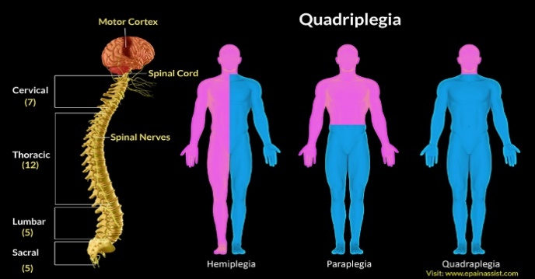
Fig. 1.1 Quadriplegic patients.
Several previous studies have been conducted to explore the potential applications for wheelchairs and home automation. This paper focuses on a system designed to assist paralyzed individuals using attention and eyeblink parameters from EEG data. The attention component of the EEG is preferred for user control, and a similar system has been developed using MATLAB to process EEG and EOG signals to control wheelchairs and home appliances. The attention level can be determined from EEG, while sudden large amplitude variations in EEG during voluntary eye blinks are used to detect eye blinks. Another study cited in the paper uses both attention and eyeblink parameters, requiring users to maintain a higher attention level during double eye blinks.
The system is designed based on previous studies and involves an EEG headset that transmits data to a microcontroller, such as Arduino UNO, via a Bluetooth module HC05. This data is processed to extract attention and the number of eyeblinks. The attention value is then used by the Arduino UNO to control the wheelchair's mobility, while the number of eyeblinks controls the direction of mobility (forward, left, and right) and the operation of electrical devices such as lights and fans in a separate environment. Two separate ESP32s control these electrical devices. The transmitter ESP32 receives the blink count from the Arduino UNO and then transmits this data to the receiver ESP32 via ESP-NOW protocol, which offers a range of approximately 220 meters. It provides fast and reliable data transmission. The received data is used by the receiver ESP32 to control the two electrical devices (light and fan) through a relay module.
The attention level, the number of eyeblinks, and the operation being carried out are displayed in real-time using a 16x2 LCD to offer a user interface.This approach has several advantages over conventional methods. First, it allows for more accurate and reliable control of wheelchair mobility and electrical devices as it uses only attention level and the number of eyeblinks, which is simpler to understand and control. Second, the threshold for attention value and the number of eyeblinks can be easily modified based on the user’s needs. Third, it does not involve physical actions or voice commands, allowing operation irrespective of noisy or dark environments and assisting people with limited mobility and vocal disorders. Fourth, it is cost-effective and easy to implement, making it accessible to a wider range of users. Fifth, it has the potential to be integrated with other technologies, such as artificial intelligence and deep learning algorithms, to further improve its performance in detecting various brain-related disorders and diseases like sleep disorders, Alzheimer’s disease, Epilepsy, and more. Overall, the hardware components, communication protocols, and data transmission protocols employed in the proposed approach are thoroughly discussed, highlighting the advantages of using neurotechnology to assist individuals with limited mobility.

Literature Survey
Electroencephalography (EEG) signal processing is a vast and critical area in neuroscience and biomedical engineering. It involves the analysis and interpretation of electrical activity recorded from the brain using electrodes placed on the scalp. Classification tasks utilize machine learning algorithms like SVM and deep learning models for tasks such as motor imagery classification and seizure detection (Reem Kateb et al.,2023). Adaptive Thresholds of EEG Brain Signals for IoT Devices Authentication, a new authentication method has been proposed for the Internet of Things (IoT) devices. This method is based on electroencephalography EEG signals, and hand gestures. The proposed EEG signals authentication method used a low price NeuroSky Mind Wave headset. This was based on choosing the adaptive thresholds of attention and meditation mode for the authentication key. Hand gestures to control authentication processes by using a general camera. The results showed that the password strength, using the proposed system is stronger than the traditional keyboard. The proposed authentication method also is resistant to target impersonation and physical observation (A. R. Elshenaway et al.,2021). EEG-based brain-controlled mobile robots can serve as powerful aids for severely disabled people in their daily life, especially to help them move voluntarily. It provides a comprehensive review of the complete systems, key techniques, and evaluation issues of brain-controlled mobile robots along with some insights into related future research and development issues. Analysis of the evaluation issues of brain-controlled mobile robots including participants, tasks and environments, and evaluation metrics (L. Bi et al.,2013). As the Home Automation is revolutionizing the lifestyles by various sensors and interface. As the Brain signals are captured by sensor placed over the head. The basic pre-processing and data refinement are performed on the sensor module itself and transmitted to the intermediate interface which is android smartphone. It also generates the controller signal if the brain reading matches with the intended response. It provides security against unauthorized control. Other features like auto sleep on unsatisfactory signal feed, programmed to reduce the false toggle of devices, three ways to control the system and scalable design are few important ones. It is extremely helpful for person with high degree of disability (G. Selvamathiseelan et al.,2022). This study involves calculating the human brain's attention level using EEG data and subsequently employing this information to operate various devices based on the attention value obtained. The process commences with multichannel EEG recordings, which are then processed using MATLAB software. The Alpha and Beta sub-bands of the EEG data are computed, and the Power Spectral Density is derived from the Alpha and Beta waves. By analyzing the intensities of the Alpha and Beta PSD signals, the subject's attention level is computed and categorized. This attention level indicator is then used to control the operation of smart home electrical devices (L. Lanka et al.,2022).

System design

3.1 Interfacing NeuroSky EEG headset
The NeuroSky headset mobile 2 has a single dry electrode which is a non-invasive BCI system as shown in the Fig 1.2.

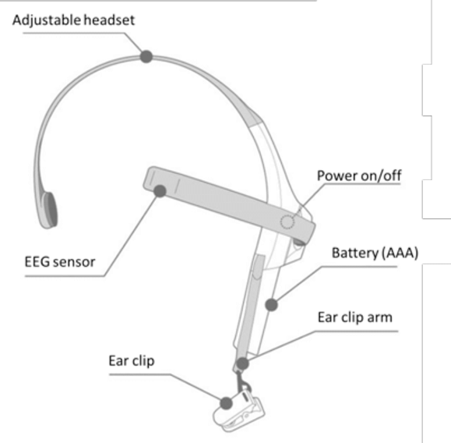
Fig. 1.2. Parts of NeuroSky EEG headset.

The electrode is to be placed on the FP1 location based on the International 10-20 system for electrode placement on a human’s scalp to acquire the Electroencephalogram (EEG) data. The FP1 location of electrode placement is located on the forehead approximately above the left eyebrow as shown in Fig 1.3.
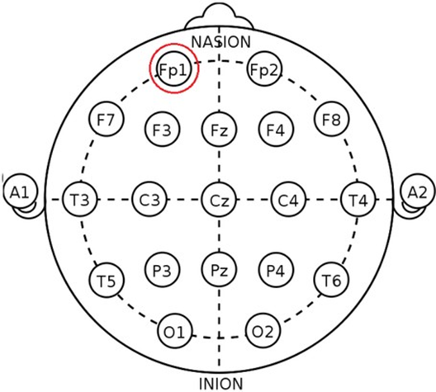

Fig. 1.3. Single dry electrode placement of NeuroSky EEG headset at FP1 location.
3.2 Wireless Data Communication Between Headset and Wheelchair
For this project, the HC-05 Bluetooth module was utilized to transfer data to the Arduino UNO development board to process and send commands for controlling wheelchairs and home automation.
To ensure successful pairing with the NeuroSky headset, the HC-05 must be set to slave mode to receive data from the headset. This can be achieved by interfacing the HC-05 into AT command mode by connecting the RX and TX to those of the controller and setting the enable pin to HIGH. The HC-05 is coded with the MAC address of the headset, as well as the username, password, mode, and UART protocol.

Proposed System Model
The system proposed is shown in Fig.1.4.
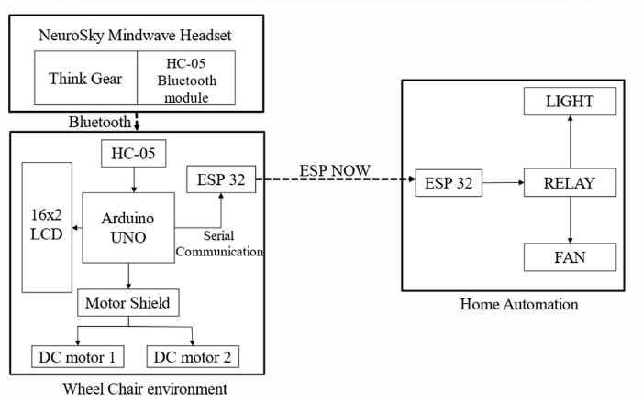
Fig. 1.4 System model.
The NeuroSky Mindwave mobile 2 headset consists of the think gear module or TGAM module along with the HC-05 Bluetooth module, the EEG data from the headset is transmitted via the HC- 05 Bluetooth module of the headset to the paired HC-05 Bluetooth module connected to the Arduino UNO.
The HC-05 Bluetooth module sends the received data to the Arduino UNO via serial communication, and the values of attention and number of eyeblinks are extracted.The attention levels are used to switch ON/OFF the two DC motors connected to the wheelchair and the number of eyeblinks is used to control the direction of movement of the wheelchair such as left and right by particularly switching ON only the right and left DC motor respectively.
The eyeblink count is also used to control the electrical devices such as light and fan, when a particular number of eyeblinks is detected the control signal is sent from the Arduino UNO to the transmitting ESP32 via software serial communication, and this control signal is transmitted to the receiver ESP32 via ESP-NOW protocol, this received data is now used by the receiver ESP32 to control the light and fan via a relay module.

Operation of Algorithm

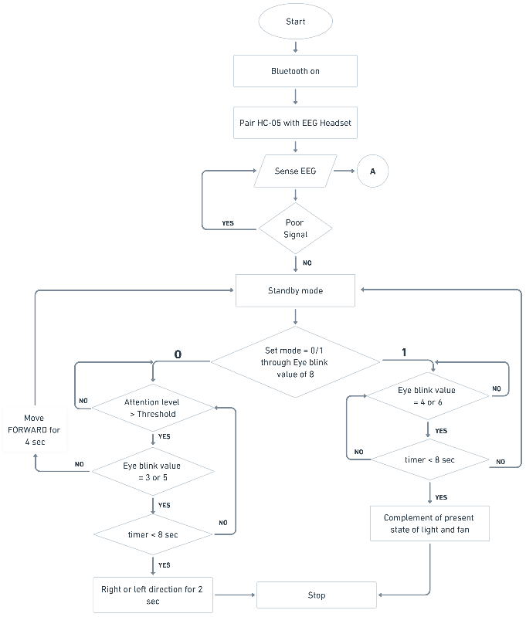
Fig.1.5 Connection Establishment
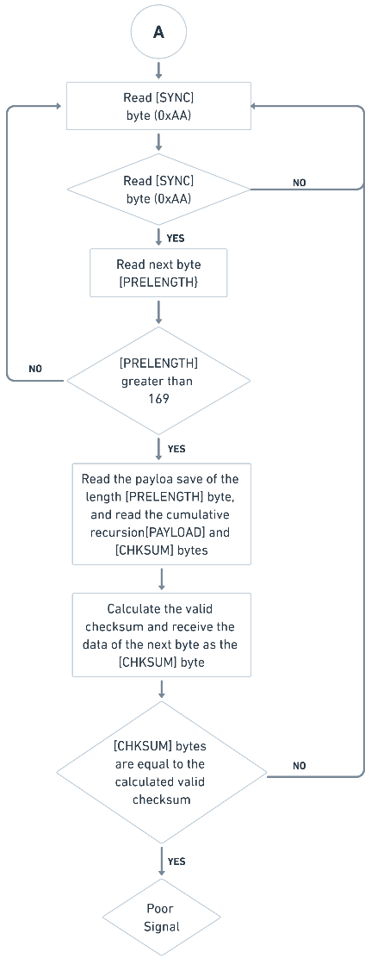
Fig.1. 6 EEG Sense
In Fig.1.5 explains the algorithms steps for home automation and wheel control. In Fig.1.6 shows the procedure to sense the EEG signal.

Algorithm for Home Automation Unit
Sender ESP32:
Step 1 : Initialization
• Create variable for receiving data and data to be sent.
• Feed the receiver MAC address to the sender ESP32.
• Define a test variable to check status connection.
• If its not delivered, retry until its delivered.
Step 2 : Main loop:
• Receive the data from the main control unit.
• Send the respective commands via dataL and dataF variable.
• If result = ESP OK.
• The command transmission is successful.
Receiver ESP32:
Step 1 : Initialization
Connect the 2-channel relay to the receiver ESP.
Define the output GPIO pins.
Define a test variable to check status connection.
Step 2 : Main loop
Receive the control data from the transmission unit.
If data.x = LON
Switch ON the light.
If data.x = LOFF
Switch OFF the light.
If data.x = FON
Switch ON the fan.
If data.x = FOFF
Switch OFF the fan.

Results and Discussion
The system continuously receives the data from the EEG headset and checks whether the of attention level and number of eye blinks match for any predefined actions. The real-time value of attention and the number of eyeblinks are displayed using a 16x2 LCD.

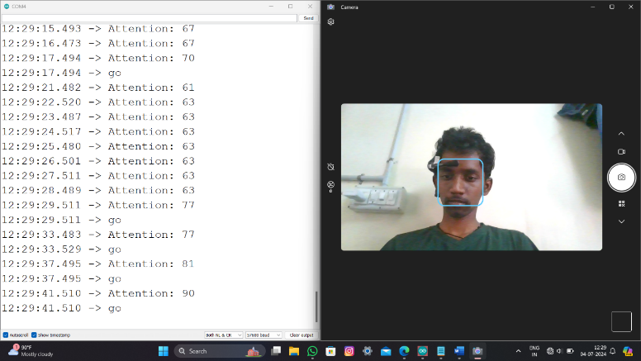

Fig. 1.7 Moving Forward

The attention level is used to drive the wheelchair forward and requires a value higher than the average threshold of 70% for movement, as shown in Fig.1.7.

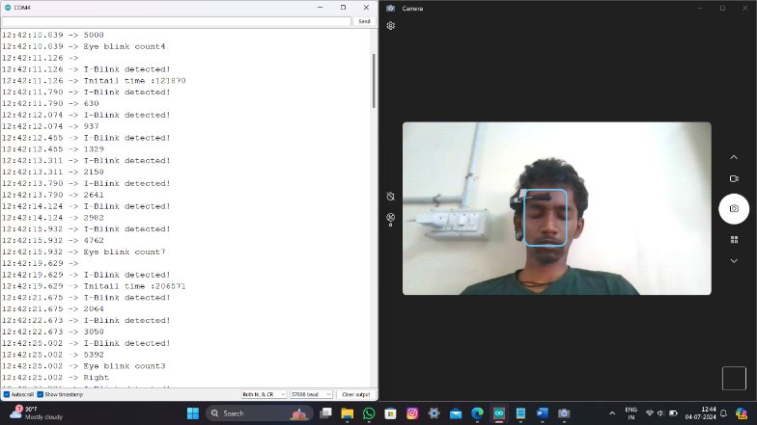

Fig.1.8 Turning Right

A decrease in the attention level value below the threshold results in the immediate stop of the wheelchair and return to the idle or normal state.

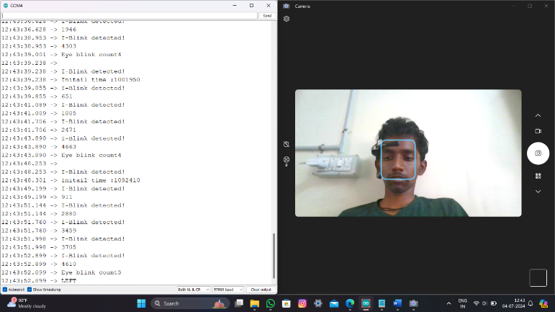

Fig. 1.9 Turning Left

The right and left movement of the wheelchair are achieved by blinking 3 and 5 times respectively followed by an eight-second interval to increase their attention level above the 70% threshold value to initiate the desired movement as shown in Fig.1.8 and Fig.1.9.

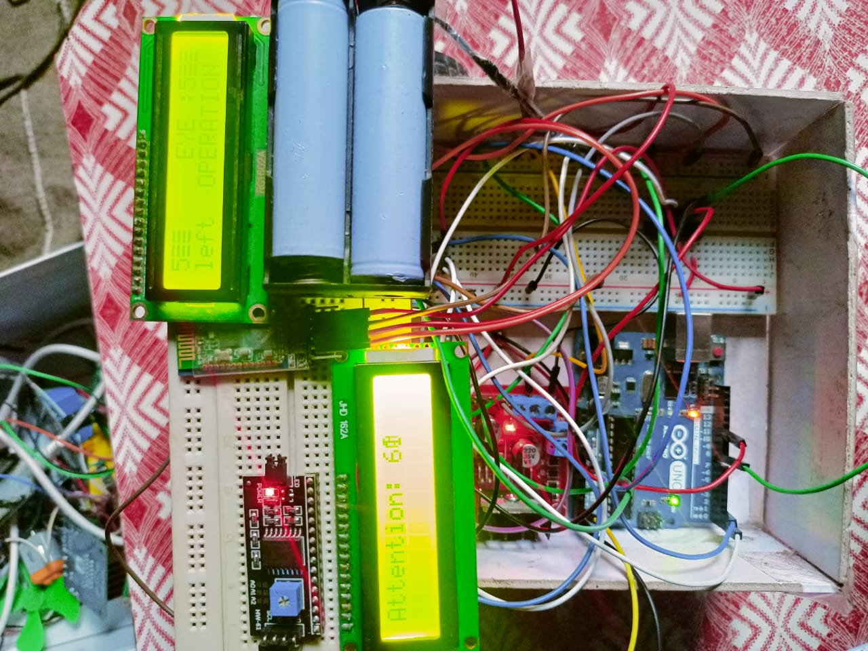

Fig.1.10 Left direction displayed in LCD

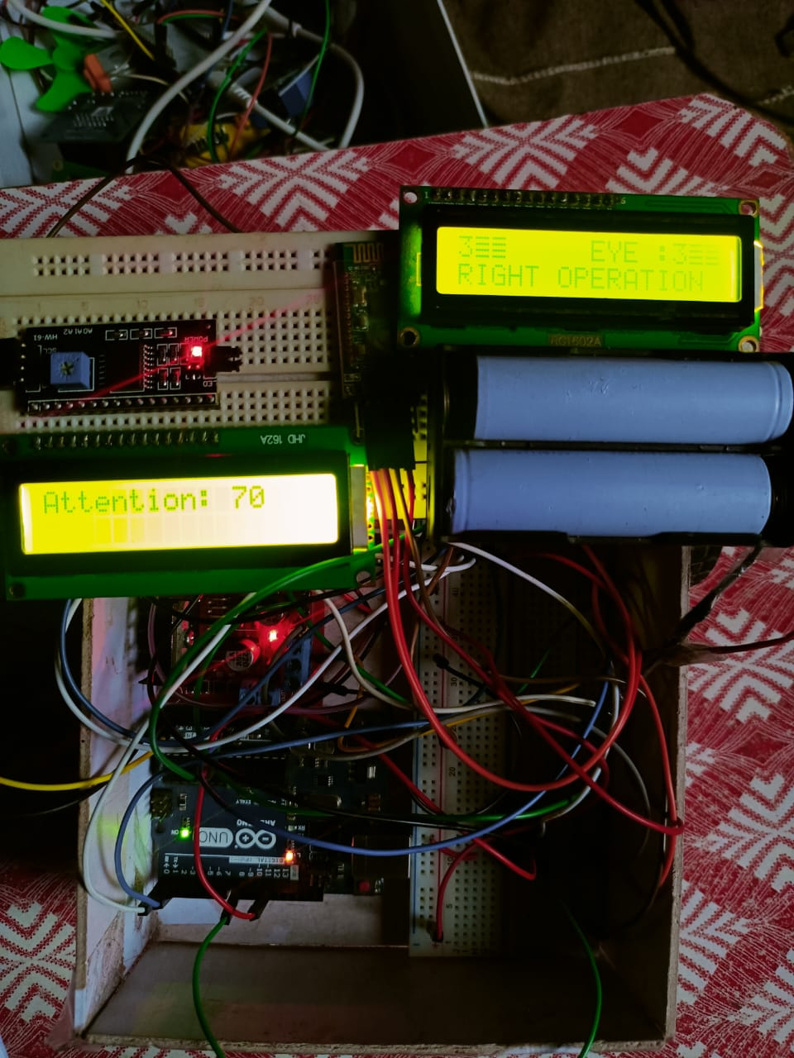

Fig.1.11 Right direction displayed in LCD

Fig.1.10 and Fig.1.11 shows the hardware model where the command is displayed in LCD for wheel chair application.

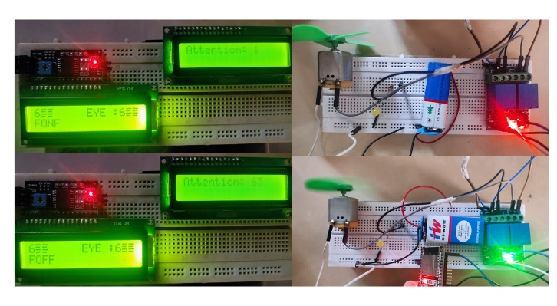

Fig .1.12. Switching ON/OFF the Fan

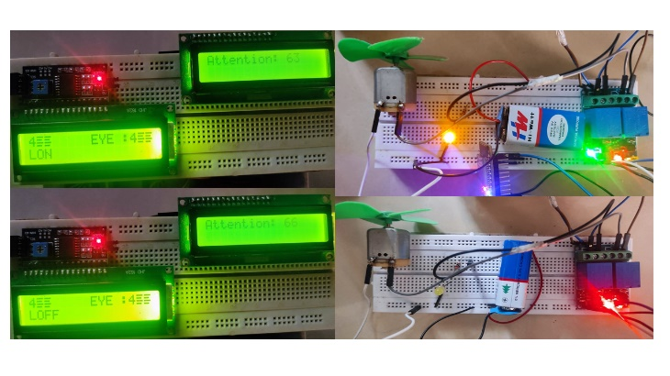

Fig.1.13. Switching ON/OFF the Light

To complement the state of light and fan the user blinks 4 and 6 times respectively, as shown in Fig.1.12 and Fig.1.13.

Conclusion
In this work, the design of a brain wave-controlled wheelchair and smart home automation for quadriplegic patients is developed. The wheelchair will be turned on and off by the attention level of the patient. The patient will be able to move the wheelchair in three directions by keeping his attention level high and with the count of eye blinks. The eye blink pattern is obtained by analysing the alpha and beta wave signals of the patient. The limitations of this work are, that the battery of the wheelchair has to be recharged after a certain period of time with the help of others, the attention level may vary drastically based on the user’s state of mind or mood, there are no means for controlling the acceleration and deceleration of the wheel chair and lack of emergency braking in case of any obstacle. These limitations can be overcome by incorporating a wireless charging method for the wheelchair’s battery, to dynamically adjust the threshold value for attention level based on the user’s state of mind through a machine learning model or by incorporating a method to adjust the attention level threshold by the user’s eyeblink, to vary the acceleration and deceleration of wheelchair by using the level of attention and to include an ultrasonic sensor to detect obstacles for emergency braking. These are the future scope of development of this work. This device will make the life of quadriplegic patients easier and more mobile.

Reference
Reem Kateb,Ahmad Chaddad, Yihang Wu (2023). Electroencephalography Signal Processing: A Comprehensive Review and Analysis of Methods and Techniques.MDPI Sensors, 23(14),2-27. https://www.mdpi.com/1424-8220/23/14/6434.
A. R. Elshenaway and S. K. Guirguis(2021). Adaptive Thresholds of EEG Brain Signals for IoT Devices Authentication. IEEE Access, 9, 100294-100307. https://ieeexplore.ieee.org/abstract/document/9467310.
L. Bi, X. -A. Fan and Y. Liu(2013). EEG-Based Brain-Controlled Mobile Robots: A Survey. IEEE Transactions on Human-Machine Systems,43(2),161-176. https://ieeexplore.ieee.org/document/6461528.
G. Selvamathiseelan, N. V. S. Pradyumna, N. N. V. Sai Prakash, V. Sudharsan Reddy and S. Yadav(2022). Brain Controlled Smart Home Automation System. IEEE Fourth International Conference on Advances in Electronics, Computers and Communications (ICAECC),Bengaluru, India, 1-5. https://ieeexplore.ieee.org/abstract/document/9716654.
R. Avudaiammal, K. J. Mystica, A. Balaji and B. Raja(2020).Brain Sense Controlled Wireless Robot: Interfacing Neurosky Brainsense to a Wheelchair Prototype, 2020 Third International Conference on Smart Systems and Inventive Technology (ICSSIT), Tirunelveli, India,276-280. https://ieeexplore.ieee.org/abstract/document/9214100.
L. Lanka, D. K. Dhulipalla, S. B. Karumuru, N. S. Yarramaneni and V. R. Dhulipalla (2022). Electroencephalography (EEG) based Home Automation for Physically Challenged People using Brain Computer Interface (BCI), 2022 International Conference on Inventive Computation Technologies (ICICT), Nepal, 683-687. https://ieeexplore.ieee.org/abstract/document/9850472.
M. S. b Abd Rani and W. bt. Mansor (2009). Detection of eye blinks from EEG signals for home lighting system activation.2009 6th International Symposium on Mechatronics and its Applications, Sharjah, United Arab Emirates, 1-4. https://ieeexplore.ieee.org/abstract/document/5164828.
M. Nafea, A. B. Hisham, N. A. Abdul-Kadir and F. K. Che Harun(2018). Brainwave-Controlled System for Smart Home Applications. 2018 2nd International Conference on BioSignal Analysis, Processing and Systems (ICBAPS), Kuching, Malaysia, 75-80. https://ieeexplore.ieee.org/abstract/document/8527397.
Chaddad, A.; Wu, Y.; Kateb, R.; Bouridane, A(2023). Electroencephalography Signal Processing: A Comprehensive Review and Analysis of Methods and Techniques. Sensors, 23, 6434. https://www.mdpi.com/1424-8220/23/14/6434.
P. Kumar Shukla and R. Kumar Chaurasiya(2018). A Review on Classification Methods Used in EEG-Based Home Control Systems. 2018 3rd International Conference and Workshops on Recent Advances and Innovations in Engineering (ICRAIE), Jaipur, India, 1-5. https://ieeexplore.ieee.org/abstract/document/8710432.
I. P. A. Kalindu, G. K. C. R. Kodikara, R. Hirshan and W. G. C. W. Kumara(2022). BRAINWAVE: EEG Based Brain and Voice Controlled Hybrid Smart Multi-Plug. 2022 6th SLAAI International Conference on Artificial Intelligence (SLAAI-ICAI), Colombo, Sri Lanka, 1-6. https://ieeexplore.ieee.org/abstract/document/10002496.

